Health and wellbing strategy
Board library reference | Document author | Assured by | Review cycle
P150 | Health and Wellbeing Lead | Quality and Standards | 3 years
This document is version controlled. The master copy is on Ourspace.
Once printed, this document could become out of date.
Check Ourspace for the latest version.
Contents

1. Introduction 3

2. Background and National context 3

3. Current Position within AWP 3

4. Objectives 4

5. Strategy overview 4

6. The five domains of the Staff Health and Wellbeing programme 5
6.1 Welfare 5
6.2 Physical Health 6
6.3 Mental Health 6
6.4 Wellbeing 7
6.5 Benefits 7

7. Underpinning elements 8

8. Manager’s toolkit – Health and Wellbeing Skills 8

9. Strategy delivery 8

10. Responsibilities 9
10.1 Board 9
10.2 Health and Wellbeing Lead 9
10.3 Managers 9
10.4 Staff 10

11. Key performance Indicators 10

12. References 10

13. Related policies 10

14. Legislative framework 11

Introduction
Avon and Wiltshire Mental Health Partnership NHS Trust (AWP) recognises that all its employees have a direct impact on clinical quality, outcomes and the experience of service users.
The Trust is committed to providing a framework to take a proactive and engaging approach to protecting and maintaining the health and wellbeing of its staff and prevention of occupational ill health.

Background and National context
The NHS Constitution places wellbeing at the heart of staff pledges. Pledge number 3 sets out that staff can expect as a minimum, from the NHS as an employer to; provide support and opportunities for staff to keep themselves healthy and safe.
The Five Year Forward View (October 2014) commits to action “ we will also establish with NHS employers new incentives to ensure the NHS as an employer sets a national example in the support it offers its own 1.3 million staff to stay healthy, and serve as ‘health ambassadors’ in their local communities”
The Health and Wellbeing of NHS staff: Dr Steve Boorman's report on the Health and Well-being of NHS Staff (November 2009) concluded that the healthcare environment can be inherently more challenging to health than other non-health sectors and NHS staff are more prone to work related injury (1.7 times more likely) and illness (1.5 times more likely.)
Boorman reports clear evidence that good staff health and wellbeing is vital for ensuring that the NHS can meet the productivity challenge it faces in the future and found that there were clear links between staff health and wellbeing and the three dimensions of service quality:
- Service user safety
- Service user experience
- The effectiveness of service user care
The Secretary of State endorsed the Boorman Review and provided the NHS with three clear messages:
- The NHS must be an exemplar employer in ensuring the health and wellbeing of its staff in order to make a real impact on the wider public health
- Good staff health and wellbeing improves the quality of services and care for our service users
- Reducing sickness absence and improving staff health and wellbeing makes a significant contribution to productivity.

Current Position within AWP
The Two largest causes of sickness absence in Trust are;
- Stress, anxiety, depression and other psychiatric illness. In the period; may 16 to April 17 the estimated cost of absence for these causes was circa £1.5 – 2.5 million
- Musculoskeletal injury (Back problems and other Musculoskeletal problems) in the period; May 2016 to April 2017 estimated cost of absence for the causes was circa £500,000 - £1million
The Trust’s current Staff Health and Wellbeing programme is aligned with the Workplace Wellbeing Charter, and has been accredited at achievement level in the following domains; Leadership; Attendance Management; Health and Safety; Smoking and Tobacco-related Ill Health; Physical Activity; Alcohol and Substance Misuse.
However not all staff are aware of what is available, and it is not equally accessible.
There are Health and Wellbeing needs specific to the Health care environment, to mental health care and the Trust, which are not considered with the Workplace Wellbeing Charter and therefore need separate consideration.
Building on previous work, this Strategy intends to consolidate the approach and extend its scope to cover areas of focus raised through staff engagement in 2016/17 and ensure universal awareness and equitable access.

Objectives
The Staff Health and Wellbeing strategy will Support the Trust’s 2017/18 objectives by
- Supporting Improvements to patient safety and clinical outcomes through reduced sickness absence and turnover of experienced staff
- Develop our culture to address issues described in staff survey results
- Improve the experience and wellbeing of staff working in AWP
- Contribute toward bringing the organisation back to financial balance through reductions in costs associated with sickness absence and staff turnover
- That Staff agrees the Trust takes positive action on Staff Health and Wellbeing.
- That sickness absence from ‘Stress, anxiety, depression and other psychiatric causes’ and Musculoskeletal disorders is reduced from the current position described above

Strategy overview
The over-arching principle is that Staff Health and Wellbeing is part of everyday business. We will focus on improving and maintaining health and wellbeing and not limiting the focus to sickness absence management.
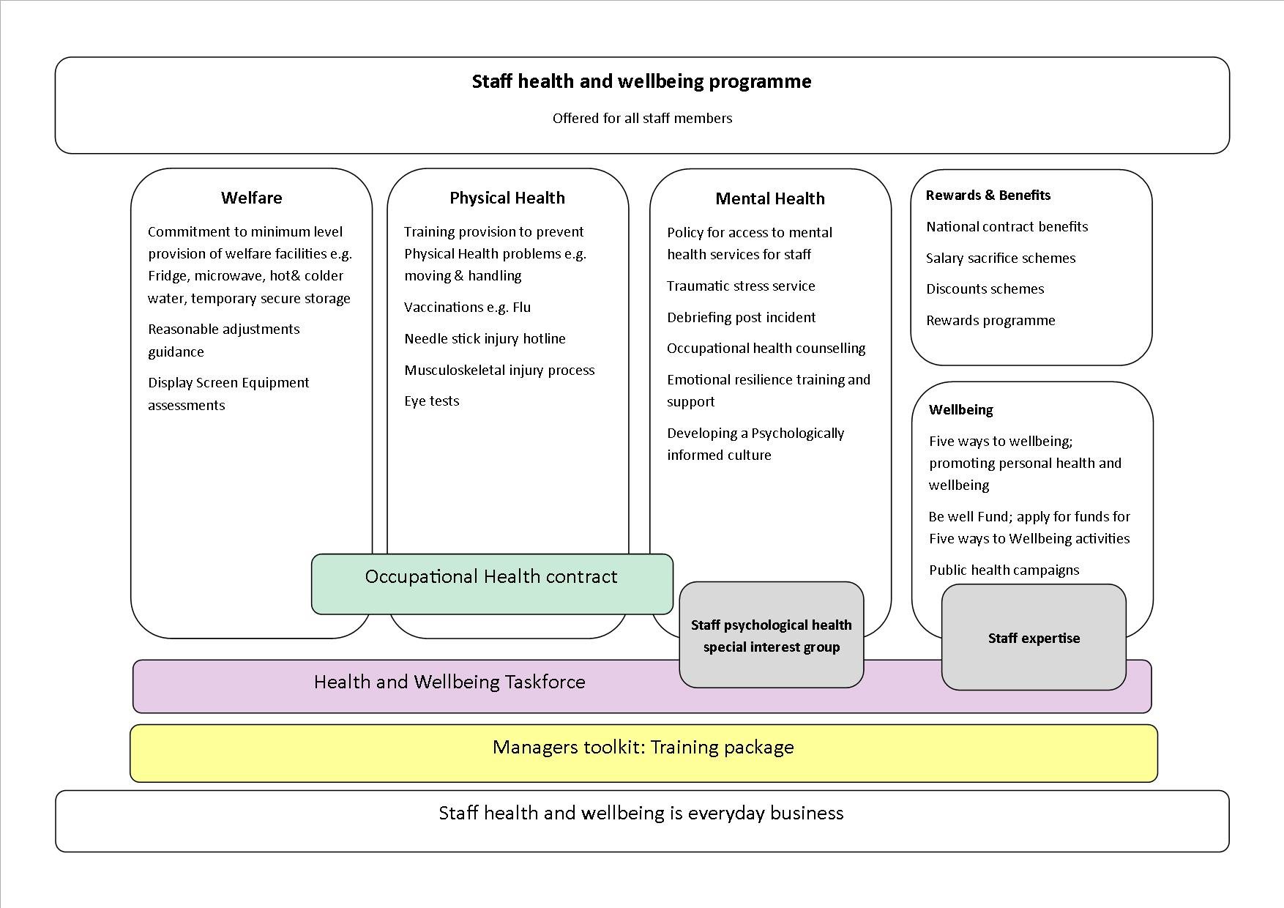
The Trust’s Staff Health and Wellbeing programme (SHWBP) has 5 domains; Welfare; Physical Health; Mental Health; Wellbeing; Rewards & Benefits which are explained in detail in the next section.
Health and Wellbeing considerations will be embedded into all relevant policies, guidance and decision making where there may be effects on Staff health and Wellbeing. Impacts will be understood in advance, and action will be taken to prevent negative consequences through the addition of Staff Health and Wellbeing to the impact assessment tool.
Staff will have clear information outlining what the staff health and wellbeing programme is how they can access it, who is responsible, what they expect and what their own responsibilities are. This access will be equitable. All staff will be provided with a physical copy of the Staff Health and Wellbeing programme; electronic copies will be available on the Trusts intranet. The staff Health and Wellbeing Programme will be covered in local and Trust induction processes.
Managers will present to their team, the Staff Health and Wellbeing Programme within 2 months of launch of this strategy.
Managers will be supported with training and resources to deliver the Staff health and Wellbeing Programme. There will be opportunities to contribute to the effectiveness of the programme.
The Staff Health and Wellbeing Programme will be underpinned with Occupational Health provision that works for both the staff member and line manager, providing a pragmatic approach.
Oversight and implementation of the Staff health and Wellbeing programme will be via the Health and Wellbeing Taskforce.
We will capitalise on the Trusts expertise in Mental and Psychological Health, Nutrition, Physical Activity, Musculoskeletal Health, and other with Trust specialists to advise approaches.
Monitoring will be undertaken through the Health and Wellbeing taskforce to ensure that Staff across the Trust experience equitable access to programme.
The organisation is Accredited with the Workplace Wellbeing Charter, we will maintain this accreditation and to sign up to the Time to Change Pledge. These are external schemes which provide benchmarks against which Trust delivery can be measured.

The five domains of the Staff Health and Wellbeing programme

Welfare
All staff will have access to a minimum level of welfare provision in order that they are able to meet their wellbeing needs. This will be access to a Fridge, hot water, drinking water, a Microwave and temporary secure storage for valuables. Higher populations of staff in a closer area may benefit from additional provision.
Monitoring will be undertaken to ensure these needs are met and maintained. Reporting where this is not the case will take place via the SHWB inbox awp.shwb@nhs.net 0601
Display screen equipment assessments are undertaken and recommended actions are followed through and equipment provided.
Workplace reasonable adjustments can be made in conjunction with your Line manager and the HR department. Guidance has been produced to enable all parties to understand what this may constitute. Additional advice is available from the Equality and Diversity Lead.
The Trust is committed to improving access to welfare provision to Staff who are nomadic workers or hot-desk.
The Trust is developing a Travel plan which will highlight a range of options designed to reduce reliance on cars and the strain on carparks whilst encouraging staff to look at healthier and more sustainable alternatives

Physical Health
The Trust acknowledges that some elements of patient care such as moving and handling patients; managing challenging behaviour and tertiary interventions come with a level of risk of physical injury, and can be unpredictable. The following actions mitigate these risks where possible
• Training. Every care is taken to reduce the above risk through individualised care planning and provision of clinical guidance and procedure. In support of these measures, training will be provided to staff covering appropriate subject areas, which aims to protect physical health and prevent injury, this includes the appropriate moving and handling training, de-escalation training and tertiary intervention training specific to an individual’s role and locations needs
The Trust will appoint subject matter experts to ensure safe and effective training provision
- Vaccinations. Flu and health care specific immunisations will be offered to staff to prevent personal ill health, alongside protecting vulnerable patients and colleagues.
- The Needle Stick Injury process will meet staff needs in a timely and appropriate manner. Psychological support will also be provided.
- A Musculoskeletal Injury process will be provided, which will look at root causes to prevent future occurrences and will include treatment options via Occupational Health will be available to enable staff to return to duties quickly, without further impact on their health.
- Eye tests for regular display screen users will be encouraged.
- Nicotine Replacement Therapy: Staff will be encouraged to take up the offer of 12 weeks Nicotine Replacement Therapy to cease smoking as per the smoke free environment policy

Mental Health
Boorman described the healthcare environment as a highly pressurised environment; constantly under public scrutiny with a considerable workload and both physically and psychologically demanding.
The Trust acknowledges the impact of the psychological and emotional demands of caring for patients.
Mental health care is a challenging environment in which to work, particularly for those who have had relatable experiences.
In order to meet the needs of this environment the Trust will develop a psychologically informed and supportive staff culture through;
Debriefing and additional post incident support
Debriefing is offered in a timely and appropriate manner after any incident which staff experience as stressful and/or traumatic.
An appropriately resourced and trained staff group are available to offer debriefing where requested.
This will be linked to the incident reporting system so that debriefing is prompted to be offered when incident form are completed.
A training programme is in place to develop an increased pool of debriefers –to whom a network meeting will be offered twice yearly.
The number of debriefs and overall effectiveness will be monitored via the Staff Psychological Health Special Interest Group.

Staff Psychological Health Special Interest Group
Led by the Health and Wellbeing Lead, a Trust wide special interest group has been formed of multidisciplinary clinical staff are able to influence and ensure the needs of their staff group are met. This will monitor and ensure effectiveness of debriefing and any post incident support.
Enhancing Emotional resilience
Training will be offered so that Staff are equipped to self-manage the demands of working in a care environment, and contribute toward a psychologically informed and supportive culture and will enable navigation of a high demand and changing environments.
Traumatic Stress service
Is available via self-referral for staff that have experienced trauma or are experiencing Post-traumatic stress disorder symptoms from a work related incident, and is provided by Trust experts.
Staff Mental Health service access
Staff are equally vulnerable to mental health difficulties, as the rest of the population. Additionally, the Trust is proactively recruiting those with lived experience of mental Health difficulties.
Work is progressing to ensure that staff are able to access all levels of Mental Health and other services that the Trust offers, and that they are not disadvantaged by their employment with the Trust. Staff will be able to receive services in a confidential and appropriate manner.
A service access policy will be produced with the agreed process for accessing care.
Occupational Health Counselling services
Counselling is available via the Occupational Health service; this referral is paid for via the team budget and will need to be made by the Team manager

Wellbeing
- Five Ways to Wellbeing campaign is an evidence based approach to improving wellbeing and is promoted widely across the Trust. It focuses on five areas: Be active; give; connect; take notice; keep learning. Through this, activities such as reading challenges, walking challenges, sports leagues, yoga session and craft groups have taken place across the Trust.
- The Be Well fund, which has implementation and oversight through the Health and Wellbeing Taskforce, will provide funding to staff for locally owned Wellbeing activity aligned to the Five Ways to Wellbeing
- National Public Health initiatives will be promoted to staff across the Trust for the dual benefits of improving staff health, and additionally as our role as exemplar employer and health ambassadors in the local community as recommended in the five year forward view. This takes a system wide view and contributes toward STP partnership working.

Benefits
Staff should be aware of the contractual benefits laid out in the NHS staff handbook and the Trust HR policies that support Health and Wellbeing.
- Workforce development fund is available for non-statutory and mandatory training
- From time to time the Trust is able to offer salary sacrifice options such as for child care vouchers, Car schemes and others.
- Discount schemes are available via Staff Benefits and Health Service Discounts
- Local rewards and discounts: Staff are encouraged to investigate offers available and share with their colleagues. Space on Ourspace will be made available to support sharing

Underpinning elements
Occupational Health provision will work for both the staff member and line manager, and provides a pragmatic approach to remaining at or returning to work.
Health and Wellbeing Taskforce consists of Locality and Directorate representatives and staff with a special interest.
Its responsibilities include;
- The opportunity for staff feedback
- Commissioning of Task and finish groups for staff health and wellbeing related tasks
- Reporting of Staff Psychological Health Special Interest Group
- Implementation and Oversight of the Be Well Fund
- Delivery of annual Staff Health and Wellbeing objectives
- Monitoring of Staff Health and Wellbeing indicators
- Promotion of five ways to wellbeing activities

Manager’s toolkit
The most important factor in Staff health and wellbeing is the relationship with the line manager, to support this crucial relationship a Managers Toolkit will be developed.
It will provide information and resources to enact the Staff Health and Wellbeing programme. It will include responsibilities, expectations, and outcomes. Training and coaching will be provided to support approaches and behaviours that promote good management practice.

Strategy delivery
Delivery and implementation of the Strategy will be overseen the Health and Wellbeing Lead.
Key partners who will assist in the delivering the strategy;
- All staff within the Trust
- Joint Union Council Representatives
- Estates and Facilities Management
- Learning and Development
- Human Resources
- Health and Safety Committee
- Strategic Workforce Group
- Health and Wellbeing Taskforce
- Freedom to Speak Up Guardian
- Staff Psychological Health special interest group
- Occupational Health
- Patient Safety
An annual Health and Wellbeing Action Plan will be developed to identify, deliver and communicate health and well-being initiatives to all employees.
Annual priorities will be determined through workforce planning data, OHS data, direct staff feedback (via Health and Wellbeing Representatives) as well as feedback from staff surveys and the Staff Psychological Health special interest group
A physical brochure with the Staff Health and Wellbeing programme will be distributed to each member of staff to promote awareness and uptake.

Responsibilities

Board
The Board through the Strategic Workforce group will be responsible for allocating resources necessary for delivering the strategy, and monitoring performance.

Health and Wellbeing Lead
The Health and Wellbeing Lead will be responsible for promoting and delivering the strategy throughout the organisation, identifying and implementing health and well-being initiatives and monitoring their effectiveness.
Activities will include:
- Identify best practice and build external links with other organisations.
- Make recommendations following consultation with staff on developments and improvements to associated policies.
- Embed health and wellbeing in policies and guidance, in changes to training, service delivery and equipment provision (this is not exhaustive) via the impact assessment tool.
- Identify training for managers.in conjunction with input from Learning and Development and HR.
- Monitoring of Welfare provision

Managers
Managers are responsible for promoting the principles and behaviours in the manager’s toolkit
- Monitor working hours to ensure staff are taking regular breaks and monitor holidays to ensure staff are taking their full entitlement at regular intervals
- Ensuring that equipment is available to meet staff welfare needs
- To ensure DSE and reasonable adjustments are continually delivered, and adjusted as necessary
- Ensuring staff understand the Staff Health and Wellbeing Programme, how they can access it and what they are responsible for
- Referring employees to occupational health when appropriate and with consent
- Ensuring employees are able and encouraged to attend for preventative treatment, e.g., vaccinations, medical appointments
- Ensuring effective communication between management and staff, particularly where there are organisational and procedural changes
- Ensuring that bullying and harassment and discrimination are not tolerated
- Identify and deal with sickness and wellbeing issues in the team ensuring advice from HR and Occupational Health provider is sought where appropriate to enable employees to remain at work or return to work with interventions
- Ensure on-going health and wellbeing issues are communicated to a senior manager/HR as soon as possible in order to secure appropriate advice and support

Staff
Employees are responsible for managing their own health, safety and wellbeing to enable them to participate fully in the working environment.
This personal responsibility will include:
- Taking advantage of training and information sources
- Recognise the limits to what they can do and seek advice at the earliest opportunity
- Ensure they take regular breaks and their full entitlement to annual leave to ensure regular rest periods
- Share ideas for promoting health and well-being in the workplace
- Accept opportunities for occupational health review when recommended
- Participate in vaccination programmes for infectious diseases

Key performance Indicators
- Improvements in staff reporting stress levels in the annual staff survey
- Improvement in staff reporting musculoskeletal injury in the staff survey
- Reduction of sickness absence rates
- Reduction in staff absence for work related stress reasons (OHS data)
- Reduction in staff turnover
- Ad hoc internal and local Surveys e.g. to evaluate health and wellbeing initiatives
- Trust workforce indicators such as Sickness absence, turnover, supervision, appraisal and personal development performance
- Occupational Health and Counselling Service trend information
- Reporting via Health and Wellbeing Taskforce Representatives
- National Surveys

References
- Boorman Report - NHS Health and Well-being Review - (2009)
- National Institute for Health and Clinical Excellence, NICE Guidance 22 - Promoting mental Health and Wellbeing at work - (2009)
- Department of Health - NHS Operating Framework for the NHS in England 2012/13 - (2011)
- Dame Carol Black Review – Working for a healthier tomorrow - (2008)
- Department of Health - NHS Constitution the NHS belongs to us all - (2010)

Related policies
- Health and safety
- Workforce Diversity and Equal Opportunities
- Dignity at Work
- Grievance and Disputes
- Managing Attendance and Absence
- Capability
- Stress Management and Wellbeing
- Flexible Working
- Information Risk
- Disciplinary
- Whistle blowing

Legislative framework
There are specific requirements placed on the trust in relation to legal responsibilities and other performance management standards. The organisation’s duty of care towards its staff is determined externally by legislation including:
- Equality Act 2010
- Employment Relations Act 1999
- Disability Discrimination Act 2005
- Special Educational Needs and Disability Act 2001
- Human Rights Act 1998
- Data Protection Act 1998
- Health and Safety at Work etc Act 1974

As an employer, Avon and Wiltshire Mental Health Partnership NHS Trust is committed to equality and valuing diversity within its workforce.
Our goal is to ensure that these commitments, reinforced by our values, are embedded in our day-to-day working practices with all our service users, carers, colleagues and partners.

Version History
Version | Date | Revision description | Editor | Status
1.0 | 11/09/2014 | New strategy agreed by ESEC on 11 September 14 | SH | Approved
1.1 | 11/09/2017 | Revised and updated | LF

