Recommendations from the South-West Clinical Senate Council on how we might ensure that children and young people waiting for paediatric specialties and/or within all-age (medical and surgical) and community pathways are appropriately prioritized and receive safe, high-quality, and timely care, whilst taking into consideration the impact on their development, future health, education, and health inequalities.

Date created: 23/11/2023
Last updated: 07/07/2024
Version: FINAL V 1.0

Prepared: Ajike Alli-Ameh, Head of South West Clinical Senate
Signed off: Dr. Sally Pearson, Chair of South West Clinical Senate

Table of Contents
1.0 Background 3
1.1 National context 3
1.2 Regional perspective 4
1.3 A growing rise in health inequality 7
1.4 Current approaches to risk stratification 9
2.0 The Question 9
3.0 Observations 10
3.1 Risk Stratification 10
3.2 Impact of deprivation 11
3.3 Waiting Well 11
3.4 Follow-up Lists 11
3.5 Resource Allocation 11
3.6 Lack of skilled and specialist workforce 11
3.7 Access to Data 12
3.8 Governance and Accountability 12
4.0 Recommendations 12
Theme: Navigating the challenges around prioritisation in the existing system 12
A. Risk Stratification 12
B. Waiting List Management 13
C. Waiting Well 14
D. The Role of the Integrated Care Boards [ICBs] 14
E. Managing Transitions 14
Theme: Making a fundamental shift in system to afford greater priority to children 14
A. Target setting 14
Appendices 16
Appendix 1: Links to speaker presentations 16
Appendix 2: Further reading and useful resources 17
Appendix 3: Senate Council membership 19
Appendix 4: Other attendees at the meeting 22

Background
‘How the South West might ensure that children and young people waiting for care are appropriately risk stratified and prioritised to ensure that they receive safe, high quality and timely care’ emerged as a deliberative topic for the Senate Council, from conversations with Dr. Vinay Takwale, Medical Director NHS England – South West who is responsible for coordinating elective care recovery in the South West region, and supported by conversations with colleagues from NHS Devon ICB, who were also aware of potential inequities in the application to children’s pathways, of tools intended for the prioritisation of adults.
Clinical colleagues in Devon ICB had explored a couple risk stratification tools, and it was felt that there would be a benefit in seeking the perspective of a wider clinical audience. The South West Clinical Senate was asked to consider what risk stratification and prioritisation process could be introduced across the South West region, to support children and young people (CYP) waiting for care, to ensure equitable access to care is provided within four groupings - Surgery, Paediatric specialities, All-age specialities, and Diagnostic Imaging.

1.1 National context
In 2023, several of the national press have carried headlines that paint a challenging picture of elective recovery of NHS services with an excessively high number of people on waiting lists, post-pandemic.
An article by Healthcare and Protection stated that at the end of March 2023, “7,331,974 people were waiting to access care and treatment, and of this number, 359,798 patients had been waiting more than a year, 10,737 patients more than 18 months, and 559 patients were waiting more than two years” (published 11 May 2023).
The Royal College of Paediatrics and Child Health (RCPCH) stated that 403,955 children were on a waiting list for consultant-led care, with 17.991 waiting for essential treatments, and that whilst progress has been made in reducing the adult backlog, the waiting list for children and young people continues to grow (published on their website dated 11 May 2023).
In a joint press release, the Royal College of Surgeons of England, Royal College of Paediatrics and Child Health, British Association of Paediatric Surgeons, and the Association of Paediatric Anaesthetists of Great Britain and Ireland, stated that “Whilst much of the initial focus around elective recovery has been on reducing the adult surgical waiting list, we are concerned that children’s waiting lists are now increasing at double the rate of adult lists while surgical activity lags behind adult activity. For children, there can be potential life-long consequences of lengthy delays for surgery. We would urge all Trusts, supported by their regional Operational Delivery Networks, to review the current situation so that children’s surgery is fully considered within the whole scope of elective recovery.” (published 24 July 2023)
To support systems, address the recovery of elective paediatric services, NHS England’s Getting It Right First Time (GIRFT) team produced a list of actions entitled ‘Closing the gap: Actions to reduce waiting times for children and young people’. This document complements NHS England’s Children and Young People Elective Recovery Toolkit.

1.2 Regional perspective
National headlines point to a growing rise in health inequalities faced by children and young people in the aftermath of the COVID-19 pandemic. The South West as a region has not been exempt from this, and the section below shows a snapshot of a few services and the impact that these factors have had in the South West region, in terms of reducing elective care capacity for paediatric services which has resulted in children waiting longer for care:
- The impact of the COVID-19 pandemic
Whilst children were generally less impacted by COVID as a disease than adults, the measures taken to limit the spread of the virus had a far more profound and sustained impact on children. It is important to note that the indirect impacts of the COVID-19 pandemic were felt most in children who already had pre-existing inequalities due to their wider determinants of health or the groups to which they belong.
The contributors are reduced access to time critical interventions for debilitating conditions, changes to the delivery of education and reduced opportunities for socialisation due to lockdown restrictions. This has further compounded a pre pandemic increase in demand for children's mental health services, an increased prevalence of overweight or obese primary-age children, and a rising number of children living in poverty.
Children’s surgical services
The National Anaesthetic Audit NAP 7 (Nov 2023), shows that in the period (2021/22), the most impacted service was children’s surgery in terms of reduction, as compared with the previous year’s activity. This was also less than a third of activity when compared with adults’ surgical services. In the South West region, children’s surgical services were reduced to 28% of the previous year. This is a significant reduction in capacity which adds to the delays in children waiting to access care.

Figure 1: UK and regional variations in the average percentage of paediatric surgery activity at R1 (blue) (October 2020), R2 (purple) (December 2020) and R3 (green) (January 2021) compared with the corresponding previous year’s activity’ taken from National Anaesthetic Audit Report (NAP7) November 2023.pp 55. (Ref. Courtman, S. 2023 A surgical perspective. SW Clinical Senate Council meeting, 23 November 2023, Online)

Children's Access to Dental Services
In the South West region, there is continuing pressure for access to dental services. As the chart below indicates, services have not caught up, since the pandemic.
 | Jan | Feb | Mar | Apr | May | Jun | Jul | Aug | Sept | Oct | Nov
Plymouth
Exeter
Torbay
North Devon
Truro
Bath
Gloucester
Swindon
Bristol
Taunton
Yeovil

Figure 2. South West Surgery in Children Operational Delivery Network – Dental extractions in Children, 2021. This graph indicates delivery of dental extractions in children under anaesthesia, red indicating when the service had ceased, and green when it had restarted. It highlights how slow areas have been to restart these services leading to significant buildup of the dental waiting list. (Ref. Courtman, S. 2023 A surgical perspective. SW Clinical Senate Council meeting, 23 November 2023, Online)
- The impact of the post pandemic elective recovery
The NHS England Elective Recovery Plan sets out the ambition to eliminate waits of more than 65 weeks by March 2024, and waits of longer than a year by March 2025, and so doing, reduce the number of patients waiting in all clinical areas. This 'targets-based approach' has determined which patients are prioritised, and this has favoured the high-volume adult waiting lists over the smaller paediatric waiting lists.
In addition, most hospitals have diverted most of their resources to address adult elective surgical activity, with paediatric surgical activity lagging behind due to lack of prioritisation. Apart from the impact on the backlog number of children waiting for care and treatment, this has led to a reduction in confidence and competence in the clinical workforce in dealing with paediatric cases, which has resulted in a reduction in willingness to operate on children – particularly the younger age ranges. The consequence has been an increase in referrals to specialist centres of non-specialist surgical cases.
- The impact of waiting for care
Outside of specialist children’s hospitals, children waiting for surgical and medical services are often on all-age lists (mixed with adults). Although there are a smaller number of children waiting for care, established prioritisation tools are not sensitive enough to pick up the future harm resulting from delays in interventions that address barriers to development (e.g., hearing or mobility).
A look at Paediatric Audiology Services
There are more than 45,000 deaf children in England – half of which were born deaf whilst the other half develop deafness in childhood. For these children, it is important that they are identified as soon as possible, and during a ‘window of opportunity’ when exposure to sound and language enables the brain to build the neural connections that allow the development of early language and cognitive pathways in a baby’s first year. If these pathways are not used in this crucial period, they will not develop, and the child is likely to face ongoing challenges. With high-quality early years support, the impacts from the deafness can be overcome and the child can go onto live a fulfilling life.
However, paediatric audiology services, in the South West region and nationally, are facing difficult challenges in the post-pandemic recovery with services under significant pressure with increasing demand, long waiting lists, staffing issues, barriers to gaining Improving Quality in Physiological Services (IQIP) accreditation and other resource or funding issues. This has meant, there is an increasing number of delayed or missed diagnoses – both of which have significant consequences for a child’s development and could have a lifelong impact on the child’s ability to fulfil their potential.
1.3 A growing rise in health inequality
Health inequalities are “unfair, avoidable differences in health across the population and between different groups within society which include life expectancy, the health conditions that they may experience and the care that is available to them.” There are different kinds of health inequality:
- Health status, for example, life expectancy
- Access to care, for example, availability of given services
- Quality and experience of care, for example, levels of patient satisfaction
- Behavioural risks to health, for example, smoking rates
- wider determinants of health, for example, quality of housing
- This means that when we talk about ‘health inequality’, it is useful to be clear on which measure is unequally distributed, and between which people.
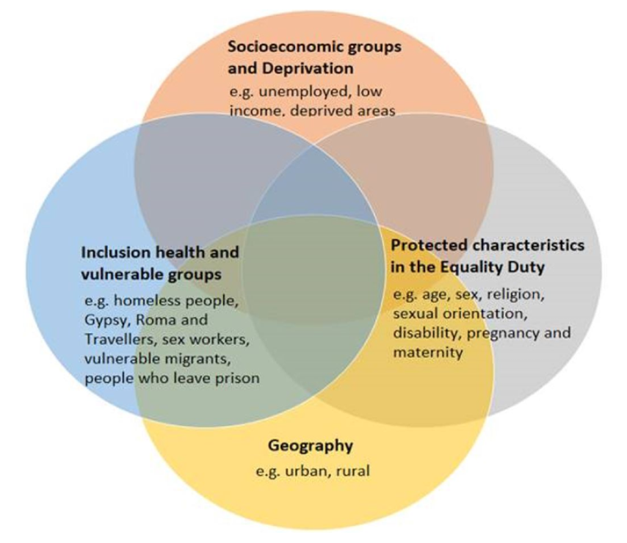
Figure: 3 The Overlapping dimensions of health inequalities (Ref. (Ref. Hooper, C. 2023 Why are Health Inequalities important when we consider prioritisation of children on waiting lists? SW Clinical Senate Council meeting, 23 November 2023, Online)
The NHS England’s Children and Young People’s Elective Recovery Toolkit recognises that long waits before accessing planned care can have lifelong consequences on the development of children and young people. The Toolkit also encourages that Systems need to embed measure to improve health and reduce CYP health inequalities. It is recognised that for children and young people from population groups with pre-existing health inequalities, the negative impacts of the waiting for care may be more greatly felt.
The example shown in Figure 4 (see below) shows the impact of inequalities and the stark difference in outcomes for two children of the same age, waiting for the same treatment, and added to the waiting list at the same time.

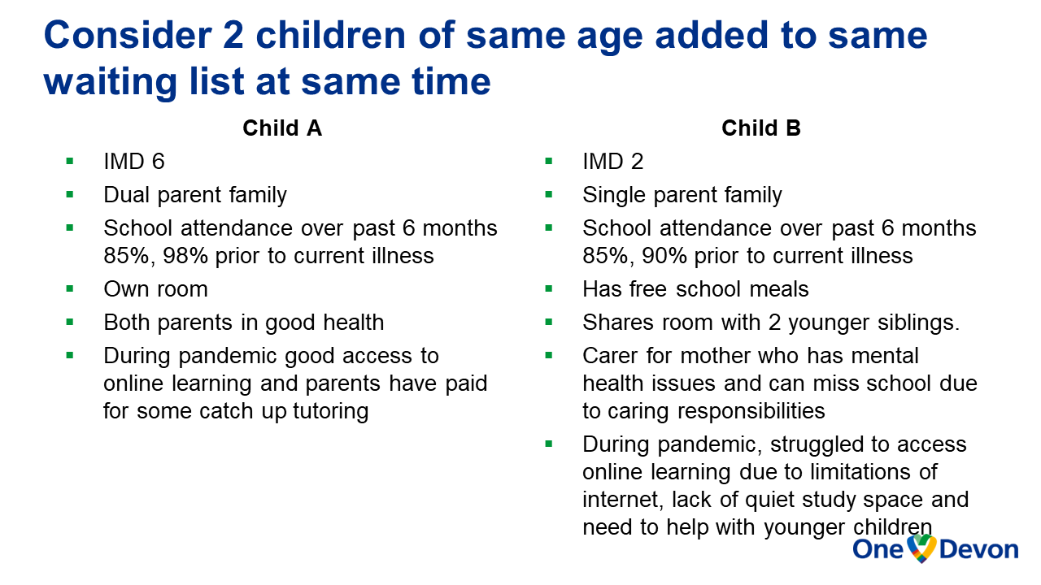
Figure: 4 This case study shows the potential negative impacts of health inequalities on outcomes for children on waiting lists (Ref. (Ref. Hooper, C. 2023 Why are Health Inequalities important when we consider prioritisation of children on waiting lists? SW Clinical Senate Council meeting, 23 November 2023, Online)
Education is a significant contributory factor to children and young people fulfilling their potential and for social mobility. However, there are population groups where children and young people are at greater risk of poorer educational outcomes – young carers, young Gypsy, Roma and Traveller (GRT) people [with only 34% of GRT children meeting expected standards in Maths in Year 2 compared to 76% of children in general population (GOV UK, April 2020)], Care leavers, and children with special educational needs and disabilities.
Long waits for these children will only further exacerbate and increase their health inequalities as they are unlikely to have access to resources or support, to enable them overcome impacts caused by the delay in treatment – particularly in terms of their education.

1.4 Current approaches to risk stratification
The consequence and potential lifelong harm of delayed access to care for children and young people have created an urgency for the stratification and prioritisation of children and young people on waiting lists, to be addressed. Current risk stratification tools capture risks to mortality and morbidity but do not take into consideration other risks such as social, educational, health inequalities, as well as the impact of delay on a child's development and future health. In addition, these tools do not take into consideration that the negative impacts will be greater for children with pre-existing inequalities which may impact on their life chances and social mobility in later life.
Two tools currently available are:
- The Children’s Hospitals Alliance (CHA) Risk Tool, developed by The Children’s Hospitals Alliance. This tool captures a holistic measure of risk to children on surgical waiting lists. It does not capture health inequalities and is not suitable for children on medical and community waiting lists.
- The Health Equity and Referral-To-Treatment (HEARTT) tool, developed by the University Hospitals Coventry and Warwickshire NHS Trust, uses clinical, social, and demographic information alongside waiting times to prioritise patients based on needs. However, there is a cost associated with procuring this tool which.
is a disincentive to some local providers.
It is important to note that both the NHS England’s Children and Young People Elective Recovery Toolkit and the GIRFT ‘Closing the gap: Actions to reduce waiting times for children and young people’ advocate the use of more holistic tools to ensure children are more appropriately prioritised for surgery. However, no tools with this capability have been introduced within the South West region, at the time of writing this report.
Similarly, there are no such tools available to risk stratify or appropriately prioritise those children who are waiting on paediatrics and community waiting lists for treatment.
This report will focus primarily on identifying risk stratification and prioritisation approaches to supporting children and young people waiting for care in the various pathways (surgical, medical, and community) to ensure equitability of care given in the South West region, setting out recommendations for systems and commissioners.

The Question
The South West Clinical Senate were posed the following question:
- How do we ensure that children and young people waiting for paediatric specialties and/or within all-age pathways (medical and surgical) and community pathways are appropriately prioritised and receive safe, high quality, and timely care, whilst taking into consideration the impact on their development, future health, education, , and health inequalities?
During the meeting, the Senate Council considered the following questions:
- How do we stratify risk in a way that identifies children who need to be seen as a priority?
- Is there a tool that can be used/ developed to support the risk stratification of children and young people (CYP) so that they are appropriately prioritised?
- How do we ensure that health inequalities are not increased whilst CYP wait for care?
- How do we manage the transition to adult services for CYP waiting for care?

3.0 Observations

3.1 Risk Stratification
- The current situation of the long lists of children waiting for care across multiple pathways is unsatisfactory and requires urgent action to be taken.
- Failure to address the impact of long wait times for time critical interventions in children will increase the burden on health and social care in the future.
- Current risk stratification tools do not take a longitudinal view of a child’s health outcomes but focus primarily on the numbers and the status and progress of the waiting lists.
- The current risk stratification tool used for all surgery, the p coding system, does not capture or consider the underlying issues as to the need for surgery in children, nor the longitudinal consequences of missing key windows for correction, both physically and mentally, which may result in lifelong impacts.
- There are risk stratification tools that can be are used to prioritise waiting lists, for example: Children’s Hospitals Alliances Risk Tool (CHART), and the Health Equity and Referral to Treatment Tool (HEARTT),. Systems should agree the consistent application of a tool which considers the impact of delay on development and the widening of inequalities.
- A Paediatric Surgical Prioritisation Tool, developed by Dr. Sarah Wimlett, Dr. Hannah Wright, and Dr. Simon Courtman, combines elements from the Children’s Hospitals Alliance Risk Tool (CHART) tool as well as assessing Health Inequalities (by looking at the deprivation index, additional needs, and neurodiversity). This tool is in its development and has not yet been validated however, it is reported to be simple and well-received during a recent pilot study involving a cohort of 75 patients.

3.2 Impact of deprivation
- There is evidence that the implementation of post-covid recovery programmes is further widening existing inequalities for children. Any prioritisation tool should be cognisant of this. The design of recovery pathways should seek to mitigate challenges of access from rural communities or those with limited digital access.

3.3 Waiting Well
- Where waiting is inevitable there should be equitable access to support to mitigate the harm from delays to treatment. This may require support to be targeted to those families with less resources (both financial and capacity and capability).

3.4 Follow-up Lists
- Most recovery programmes target those individuals who are waiting to be assessed or listed for an intervention, which means those waiting a ‘follow-up’ are delayed. Many children are on “follow-up lists” as they have known conditions that need monitoring and interventions in future. These lists are typically less visible, but any risk stratification tool chosen would need to be regularly applied to children on these lists too.

3.5 Resource Allocation
- The National Policy approach to elective recovery is focused on the adult population where the numbers are greater. This results in resource allocation decisions which not only fail to prioritise children but may reduce existing resources for children’s services. Paediatric surgery is often competing for resources, where they are shared with adult services such as, theatre capacity and workforce. During the pandemic, some hospitals decided to repurpose the clinical spaces that would have been used by paediatric outpatient services, to allow for the provision of additional adult beds. In many cases, these physical spaces have not been returned to the paediatric services for normal clinical practice resulting in a loss of clinical capacity.
- Over the last year national policy has placed an increasing focus on elective recovery in CYP services which affords the opportunity to provide equity and explicit understanding of the differences and impact on CYP waiting for clinical interventions.

3.6 Lack of skilled and specialist workforce
- The Senate Council observed that the centralisation of paediatric surgical services does have the capacity to deskill the local services. This has been exacerbated by the reduced paediatric surgical activity both during the pandemic and in the recovery.

- The development of the specialist workforce to respond to the needs of children has resulted in a reduction in paediatric training for more generalist roles. This is a significant contributory factor to the level of capacity and confidence within local services to tackle the children’s cases in the elective care backlog .

3.7 Access to Data
Children may be on waiting lists within hospitals in paediatrics, or on all-age waiting lists amongst adults waiting to see specialists for medical or surgical conditions. They may also be on community provider waiting lists for other professionals such as speech and language therapists, occupational therapists or CAMHS as examples. Data on hospital waiting lists is more easily accessible than those on community provider waiting lists, but it is still challenging to identify children on all-age waiting lists or where their episode of care has not been read-coded correctly. Community waiting lists are somewhat more challenging and children may need to see several professionals as part of their pathway of care before a diagnosis can be made or treatment started. Systems do not have well enough developed information systems to give visibility of the entire experience for the child and their families.

3.8 Governance and Accountability
Whilst there are children and young people programmes (with a limited scope) at a regional, and an ICS level, the lines of accountability are disparate, and level of priority given to these programmes is not well defined and varies across. ICSs.

4.0 Recommendations
The South West Clinical Senate makes the following recommendations which are loosely grouped into two themes:
- navigating the challenges around prioritisation in the existing system
- a fundamental shift in the system to afford greater priority to healthcare services to children and young people.

Theme: Navigating the challenges around prioritisation in the existing system

Risk Stratification
- The Senate Council recommends that the South West region commits to the introduction of a risk stratification tool that is capable of taking into account the impact of waiting (in terms of consequences, likelihoods, and outcomes). This tool needs to be simple, replicable, and universally applied across surgical, medical, and community pathways. The Paediatric Surgical Development Tool developed in Devon could be a good starting point.

- Resources should be allocated to support further development and evaluation of a tool. The tool must be validated to ensure sensitivity and specificity. The Health Innovation Networks could help assist with the validation process.

- Children and their families should be involved in the development of the risk stratification tool.

- The risk stratification tool should take a holistic needs-based approach for children and their families. It should be a multi-dimensional assessment tool and assess against an agreed set of parameters namely:
- Clinical
    - age: i.e., the ‘under-fives’ age group because of the impact on a child’s development, as the first years of a child’s life have a significant role in determining their chances in later life and is a crucial period when the gap in outcomes between children from different socio-economic backgrounds first takes hold. In addition, in relation to ‘periods before milestone exams' such as GCSE, A levels, etc.
    - stage of development: there is recognition that some types of treatment will have more impact on a child’s development e.g., mobility issues in a very young child who requires orthopaedic surgery will have a greater impact on their development than an older child of 9 or 10 years.
- Broader determinants including Social, Wellbeing, Educational, Employment, Economic, Psychological factors (SWEEEP). These will capture the child and their family’s circumstances and any factors that increase the risk of experiencing health inequalities. It is important to understand the negative impacts of waiting for care, and any indirect consequences in terms of their education, will be felt greatest by those children who have pre-existing inequalities. For example, if a child on a waiting list, is young carer – not only is there a risk of a negative impact on their education, but they may also be unable to continue providing carer support in the family, due to their medical condition/ illness. This could have a significant impact on the family.
This may lead to prioritisation decisions that differentially favour children at certain ages or certain socio-economic groups.

Waiting List Management
- The Senate Council recommends that there is a mechanism to highlight children on all-age waiting lists.
- The Senate Council recommends that there are regular reviews of all children on waiting lists, considering any changes in circumstances. A ‘curator’ role should be introduced, who would keep in regular contact with the child on the waiting list and their family, and other professionals involved in their care (health visitors, school nurses etc.) so that they receive updates on any changes in circumstances which could result in a change in priority.

Waiting Well
- The Senate Council is not aware of the provision of waiting well services for children and young people in the South West region. The Council recommends that work is undertaken to determine what a Waiting Well service for CYP in the South West, should look like.

The Role of the Integrated Care Boards [ICBs]
- The Senate Council recommends that targets relating to the elective recovery for children and young people should be set nationally for each ICB relating to reducing the harm to children and young people whilst waiting for an intervention. This will help to reduce local variance and ensure equity.
- The Senate Council recommends that there should be greater access and timely provision of data to the ICBs to create visibility of CYP on waiting lists for all children services.

Managing Transitions
- If a young person has been waiting for a year on a paediatrics waiting list, the length of time they have waited needs to be considered to ensure they are not disadvantaged or discriminated against when moved onto an adult waiting lists, having turned 18. The Senate Council recommends that there should be mechanisms in place to ensure that children are not disadvantaged when transitioning to adult waiting lists.

Theme: Making a fundamental shift in system to afford greater priority to children

Target setting
- The NHS England’s Delivery Plan for tackling the COVID backlog of elective care has at its heart the ambition is to reduce elective care waiting lists to 65 weeks by March 2024, and 52 weeks by March 2025. Funding is assigned within the Plan against the delivery of Referral-To-Treatment (RTT) targets which prioritises individuals that have been waiting the longest. Typically, the adults who make up the larger proportion of those on waiting lists fall within this patient cohort and are prioritised to receive care. So, systems focus on meeting the RTT targets, but could still have many children and young people on their waiting lists, as children may not have ‘waited long enough’ to fall within the patient cohort, prioritised to receive care. However, this masks the reason why the child is on the waiting list, in the first place. If it is to address a developmental problem, it is crucial that the care intervention is carried out within a time ‘window’. If the care or treatment is delayed beyond this ‘window’, it could result in harm and lifelong health issues for the child.

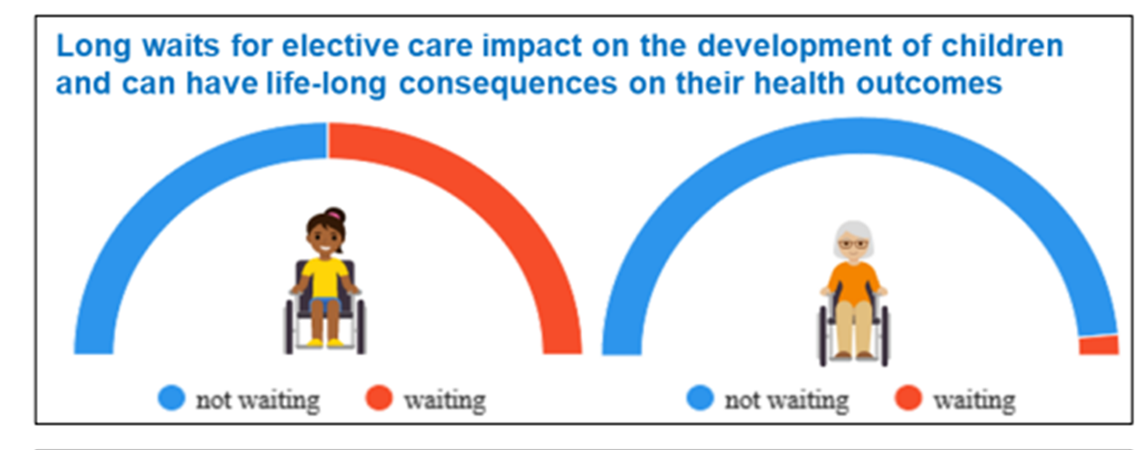
Figure 5: Ref. NHS England, 2022
- The Senate Council recommends that timely data is made available, so that the impact of waiting for care, by children and young people, can be clearly understood and that specific NHS England ‘CYP- related’ targets be set to capture activity for children and young people or the allocation of resources to child health activities.
- The Senate Council recommends that resourcing decisions at ICB, Regional, and National levels are reviewed to understand the resources that are allocated to benefit children.
- Whilst the clinical rationale for the centralization of children’s services is understood, more consideration should be given to the development of network models that help to maintain capability, capacity and confidence at a local level.
- The South West region is a Marmot region which creates an opportunity to create linkages with the work of the regional Marmot project team. The Marmot team is looking at health inequalities in children and young people, with a special focus on the return on investment, on investing in children and young people. The Marmot Team should give prominence to the prioritisation of tackling the paediatric waiting lists as part of this work.
These recommendations will be shared with the NHS England Children and Young People Transformation/ Elective Recovery Team, CYP Elective Recovery Steering Group, South West Surgery in Children Operational Delivery Network, the South West Region’s ICBs (Devon, Dorset, Somerset, Gloucestershire, Plymouth, Bristol, North Somerset and South Gloucestershire [BNSSG], Cornwall and the Isles of Scilly, Bath and North East Somerset, Swindon and Wiltshire), NHS England – South West Medical Directors, NHS England South West Region Healthcare Scientist, and Devon Elective Care Board Senior Leaders (provider organisations). It will also be published on the website of the South West Clinical Senate.

Appendices

Appendix 1: Links to speaker presentations

Speaker presentations are available to download on the South West Clinical Senate website. Please follow link to the website: Home - South West Senate (swsenate.nhs.uk)
Title | Speaker | Link
Scene setting
A surgical perspective | Dr. Simon Courtman, Care Group Director Women's and Children's Services at University Hospitals Plymouth, Clinical Director SW Surgery in Children Operational Delivery Network
A medical and community perspective | Dr. Rowan Kerr-Liddell, Consultant Paediatrician with Expertise in Cardiology, Torquay, Torbay General District Hospital
Health inequalities | Dr Claire Hooper, Deputy Strategic Clinical Advisor Planned Care, NHS Devon
A Case Example: The Impact & Harm for CYP of waiting and delays in Paediatric Audiology | Sarah Cooper, Regional Lead Healthcare Scientist - South West, NHS England, Chief Clinical Cardiac Scientist Training and Development Lead, Royal Cornwall Hospital NHS Trust  Stuart Harris, Paediatric Audiologist, University Hospitals Plymouth
Reflections from the Citizens Assembly: A patient and public perspective | Debbie Rigby, Chair of Citizens Assembly

Appendix 2: Further reading and useful resources

www.england.nhs.uk. (May 2021). NHS England» Good communication with patients waiting for care. [online] Available at: https://www.england.nhs.uk/publication/good-communication-with-patients-waiting-for-care/. [Accessed 29 November 2023]
www.england.nhs.uk. (February 2022). NHS England» NHS launches online platform to empower patients as they wait for care. [online] Available at: https://www.england.nhs.uk/2022/02/nhs-launches-online-platform-to-empower-patients-as-they-wait-for-care/. [Accessed 29 November 2023]
www.england.nhs.uk. (May 2023). NHS England» Children and young people’s elective recovery toolkit. [online] Available at: https://www.england.nhs.uk/long-read/children-and-young-peoples-elective-recovery-toolkit/. [Accessed 29 November 2023]
www.cqc.org.uk. (n.d.). State of Care 2022/23 - Care Quality Commission. [online] Available at: https://www.cqc.org.uk/publications/major-report/state-care/2022-2023. [Accessed 29 November 2023]
Transition & Patient Empowerment Innovation, Education and Research (TIER)Network. (n.d.). TIER Homepage. [online] Available at: https://www.readysteadygo.net/. [Accessed 29 November 2023]
Campbell, D., and editor, D.C.H. policy (2023). Sick children’s health worsening as record numbers wait for NHS care in England. The Guardian. [online] 17 Sep. Available at: https://www.theguardian.com/society/2023/sep/17/sick-children-health-worsening-record-numbers-wait-for-nhs-care-in-england [Accessed 29 November 2023].
Simons, G. (2023). NHS waiting lists hit 7.3m with record children’s wait times a ‘national scandal.’ [online] Health & Protection. Available at: https://healthcareandprotection.com/nhs-waiting-lists-hit-7-3m-with-record-childrens-wait-times-a-national-scandal/ [Accessed 30 Nov. 2023]
The Independent. (2023). NHS failing to tackle children’s surgery waiting lists as backlog hits record levels. [online] Available at: https://www.independent.co.uk/news/health/nhs-children-surgery-waiting-list-b2333261.html [Accessed 30 Nov. 2023].
The Independent. (2023). Children waiting years for community care as NHS chiefs slam government inaction. [online] Available at: https://www.independent.co.uk/news/health/nhs-children-waiting-list-england-b2432337.html [Accessed 30 Nov. 2023].
Closing the gap: Actions to reduce waiting times for children and young people. (2023). [online] Getting it Right First time, NHS England, p.1-6. Available at: https://gettingitrightfirsttime.co.uk/wp-content/uploads/2023/09/Closing-the-gap-Actions-to-reduce-waiting-times-for-children-and-young-people-FINAL-V2-September-2023.pdf [Accessed 30 Nov. 2023].
‌From the pond into the sea: Children’s transition to adult health services. (2014). [online] Care Quality Commission, England: Care Quality Commission, p.1 -72. Available at: https://www.cqc.org.uk/sites/default/files/CQC_Transition%20Report.pdf [Accessed 30 Nov. 2023].
‌Listening to Young People about health and social care in York! (2020). [online] Healthwatch York, pp.1–34. Available at: https://www.healthwatchyork.co.uk/wp-content/uploads/2020/03/Healthwatch-York-CAYP-report-A4-Final-Version33101.pdf [Accessed 30 Nov. 2023].

NICE guidance on Health Inequalities includes mapping to frameworks such as Marmot and Labonte, and Core20PLUS5 children and young people priority areas for improvement (which includes the oral health clinical area). https://www.nice.org.uk/about/what-we-do/nice-and-health-inequalities
NICE guidance Transition from children’s to adults’ services for young people using health or social care services [NG43]. This covers the period before, during and after a young person moves from children’s to adults services.
NICE guidance: Transition from children’s to adults’ services [QS140] covers the period before, during and after a young person (aged up to 25) using children’s health and social care services who are due to make the transition to adults’ services.
CQC is incorporating Transition from Childrens to Adult Services within Single Assessment Framework underpinned by NICE guideline and quality standard on transition. Safe systems, pathways and transitions - Care Quality Commission (cqc.org.uk)

Appendix 3: Senate Council membership
The table below shows the Senate Council membership (at the time of writing this report) with those that attended the meeting highlighted in blue.
Membership type | Name | Job Title | Organisation | Attendance at meeting
Standing Member | Dr Sally Pearson | Chair of South West Clinical Senate | South West Clinical Senate | Yes
Standing Member | Prof David Halpin | Consultant Physician and Honorary Professor & Vice Chair of Clinical Senate | Royal Devon and Exeter Hospital, South West Clinical Senate | Yes
Standing Member | Debbie Rigby | Chair of Citizens’ Assembly | Citizens Assembly (Patient & Public Partner) | Yes
Standing Member | Debi Reilly | Regional Director South West | NHS England South West | No
Standing Member | Mark Juniper | Medical Director for the WEAHSN | West of England Academic Health Science Network | No
Standing Member | Dan Lyus | Deputy CEO of the SW AHSN. | SWAHSN | No
Standing Member | Rebecca Whitting | Interim Portfolio Director - Implementation | SWAHSN | No
Standing Member | Prof Maggie Rae | President of the RSM Epidemiology and Public Health Section, Deputy Director – Regional Public Health Programmes, NHS England – South West | NHS England SW | Yes
Core member | Dr Steve Jones | Consultant Paediatrician and Neonatologist | Royal United Hospitals Bath NHS FT | No
Core member | Prof Parag Singhal | Consultant General Medicine, Diabetes and Endocrinology | UHBW Foundation Trust | No
Core member | Dr Christine Spray | Consultant in Paediatric Gastroenterology, Hepatology and Nutrition (PGHAN) | United Hospital Bristol Healthcare Trust | Yes
Core member | Dr Giorgio Gentile | Consultant Nephrologist | Royal Cornwall Hospitals NHS Trust | Yes
Core member | Dr Nick Kennedy | Consultant Anaesthetist and Intensivist | Taunton and Somerset NHS Trust | Yes
Core member | Prof Minesh Khashu | Clinical Lead for Poole Hospital | University Hospital Dorset | No
Core member | Dr Anne Frampton | Consultant in Paediatric Emergency Medicine | UHBW Foundation Trust | No
Core member | Dr Katie Cross | Consultant General Surgeon | Northern Devon Healthcare Trust | No
Core member | Dr Ann Lyons | Consultant Colorectal Surgeon | North Bristol NHS Trust | No
Core member | Dr Neil Hopper | Consultant Vascular Surgeon | Royal Cornwall Hospitals Trust | No
Core member | Rebecca Reynolds | Director of Public Health | BATHNES Council | Yes
Core member | Dom Williamson | Consultant Emergency Medicine | North Bristol NHS Trust | Yes
Core member | Dr Paul Winterbottom | Consultant Psychiatrist | 2gether NHS Foundation Trust | Yes
Core member | Dr Anita Pearson | Specialist in gender health care | Devon Partnership Trust | No
Core member | Dr Tom Hilliard | Consultant Respiratory Paediatrician | University Hospitals Bristol & Weston NHS Foundation Trust | Yes
Core member | Peter Davis | Consultant Paediatric Intensivist | University Hospitals Bristol NHS Foundation Trust | Yes
Core member | Miles Wagstaff | Consultant Paediatrician, Neonatologist | Gloucestershire Hospitals NHS Foundation Trust | No
Core member | Will Mongare | Clinical Nursing and Quality Manager / CAMHS Case Manager | NHSE/I | No
Core member | Carol Stonham | Respiratory Nurse Specialist Primary Care | Gloucestershire ICB | No
Core member | Dr Clare Barlow | Consultant Medical Oncologist | Musgrove Park Hospital | Yes
Core member | Dr Marion Andrews-Evans | Executive Nurse | Gloucestershire ICB | Yes
Core member | Joanne Meacham | Head of Nursing Adult Community Services |  | Yes
Core member | Dr Peter Wright | Director of Healthcare Science and Technology | University Hospitals Plymouth NHS Trust | No
Core member | Dr Sara Evans | Consultant Geriatrician, Lead for Medical Education research and development, and medical workforce | Royal United Hospital Bath | No
Core member | Dr Rachel Bradley | Consultant Geriatrician | Bristol Royal Infirmary University Hospitals Bristol & Weston Trust [Care of Older People] | Yes
Core member | Mark Stone | Pharmacist Consultant/Devon LPC Project Lead, Vice Chair of the East Cornwall Primary Care Network | Devon Local Pharmaceutical Committee and Tamar Valley Health Practices | No
Core member | Bruce Daniel | Head of Pathology, South West region | NHS England – South West | Yes
Core member | Alex Sharp | Head of Clinical Development | SWASFT | No
Core member | Alyson O’Donnell | Medical Director | Royal Bournemouth and Christchurch Hospital NHS Trust | No
Core member | Dr Mary Backhouse | GP | North Somerset CCG | No
Core member | Dr Amelia Randle | Clinical Lead SWAG Cancer Alliance and GP | Somerset CCG | No
Core member | Richard Walters | Physiotherapy | University Hospitals Plymouth NHS Trust | No
Core member | Ros Wade | Head of Therapy Services | Royal Devon & Exeter NHS Foundation Trust | Yes
Core member | Dr Emma Jones | Consultant Healthcare Scientist in GI Physiology | University Hospital Southampton | Yes
Co-opted member | Dr Geeta Iyer | Chief Medical Officer | BNSSG ICB | Yes
Co-opted member | Dr Amanda Webb | Chief Medical Officer | BANES ICB | No
Co-opted member | Dr Andrew Seymour | Chief Medical Officer | Gloucestershire ICB | No
Co-opted member | Dr Nigel Acheson | Chief Medical Officer | Devon ICB | No
Co-opted member | Dr Bernie Marden | Chief Medical Officer | Somerset ICB | Yes
Co-opted member | Dr Helen Skinner | Chief Medical Officer | Cornwall ICB | No
Co-opted member | Dr Paul Johnson | Chief Medical Officer | Dorset ICB | No
Non-Voting member | Jane Jacobi | Implementation Facilitator, NICE Field Team | National Institute for Health and Care Excellence | Yes
Non-Voting member (professional in training) | Dr Matthew Boissard-Cooke | Neurosurgery Specialist Registrar | University of Hospitals Plymouth NHS Trust | Yes
Non-Voting member (professional in training) | Dr Hannah Lyons | Medical Oncology Registrar | Bristol Haematology Oncology Centre | No

Appendix 4: Other attendees at the meeting

Citizens’ Assembly representatives
Citizens Assembly representatives | Nick Pennell | Member | Citizens Assembly | Yes
Citizens Assembly representative | Joanna Parker | Member | Citizens Assembly | Yes

Senate Assembly representative
Senate Assembly representative (as observer) | Dr Tom Fontaine | Consultant Paediatrician | Royal Cornwall Hospitals | Yes

https://www.theguardian.com/society/2023/sep/17/sick-children-health-worsening-record-numbers-wait-for-nhs-care-in-england
https://www.independent.co.uk/news/health/nhs-children-surgery-waiting-list-b2333261.html
: https://www.independent.co.uk/news/health/nhs-children-waiting-list-england-b2432337.html
NHS waiting lists hit 7.3m with record children's wait times a 'national scandal' - Health & Protection (healthcareandprotection.com)
Record high: Over 400,000 children waiting for treatment amidst child health crisis | RCPCH
[Ref. Courtman, S. 2023. A surgical perspective, SW Clinical Senate Council meeting, 23 November 2023, Online])
Closing-the-gap-Actions-to-reduce-waiting-times-for-children-and-young-people-FINAL-V2-September-2023.pdf (gettingitrightfirsttime.co.uk)
NHS England » Children and young people’s elective recovery toolkit
NAP7 Report | The Royal College of Anaesthetists (rcoa.ac.uk).
C1466-delivery-plan-for-tackling-the-covid-19-backlog-of-elective-care.pdf (england.nhs.uk)
Internal report (ndcs.org.uk)
NHS England » What are healthcare inequalities?
The Children’s Hospitals Alliance Risk Tool (CHART) - Children's Hospital Alliance (childrenshospitalalliance.co.uk)
What matters when waiting? – involving the public in NHS waiting list prioritisation | The Strategy Unit (strategyunitwm.nhs.uk)
The Children’s Hospitals Alliance Risk Tool (CHART) - Children's Hospital Alliance (childrenshospitalalliance.co.uk)
What matters when waiting? – involving the public in NHS waiting list prioritisation | The Strategy Unit (strategyunitwm.nhs.uk)
The Children’s Hospitals Alliance Risk Tool (CHART) - Children's Hospital Alliance (childrenshospitalalliance.co.uk)

